**Semester 2 (Units 3 and 4) Examination, 2019**

**Question/Answer Booklet**

**MATHEMATICS APPLICATIONS**

**Section One: Calculator-free**

Student Name/Number: ______________________________________________

Teacher Name: ______________________________________________

**Time allowed for this section**

Reading time before commencing work: five minutes

Working time: fifty minutes

**Materials required/recommended for this section**

***To be provided by the supervisor:***

This Question/Answer Booklet

Formula Sheet

***To be provided by the candidate:***

Standard items: pens (blue/black preferred), pencils (including coloured), sharpener,

correction fluid/tape, eraser, ruler, highlighters

Special items: nil

**Important note to candidates**

No other items may be taken into the examination room. It is **your** responsibility to ensure that you do not have any unauthorised material. If you have any unauthorised material with you, hand it to the supervisor **before** reading any further.

**Structure of this paper**

|  |  |  |  |  |  |
| --- | --- | --- | --- | --- | --- |
| Section | Number of questions available | Number of questions to be answered | Working time (minutes) | Marks available | Percentage of exam |
| Section One: Calculator-free | 6 | 6 | 50 | 50 | 35 |
| Section Two: Calculator-assumed | 11 | 11 | 100 | 102 | 65 |
|  | | | | | 100 |

**Instructions to candidates**

1. The rules for the conduct of School exams are detailed in the *_______________________________________School/College assessment policy*. Sitting this examination implies that you agree to abide by these rules.
2. Write your answers in this Question/Answer booklet preferably using a blue/black pen. Do not use erasable or gel pens.
3. You must be careful to confine your answer to the specific question asked and to follow any instructions that are specified to a particular question.
4. Show all your working clearly. Your working should be in sufficient detail to allow your answers to be checked readily and for marks to be awarded for reasoning. Incorrect answers given without supporting reasoning cannot be allocated any marks. For any question or part question worth more than two marks, valid working or justification is required to receive full marks. If you repeat any question, ensure that you cancel the answer you do not wish to have marked.
5. It is recommended that you do not use pencil, except in diagrams.
6. Supplementary pages for planning/continuing your answers to questions are provided at the end of this Question/Answer booklet. If you use these pages to continue an answer, indicate at the original answer where the answer is continued, i.e. give the page number.
7. The Formula sheet is not to be handed in with your Question/Answer booklet.

**Section One: Calculator-free 35% (50 Marks)**

This section has **6** questions. Answer **all** questions. Write your answers in the spaces provided.

Supplementary pages for the use of planning/continuing your answer to a question have been provided at the end of this Question/Answer booklet. If you use these pages to continue an answer, indicate at the original answer where the answer is continued, i.e. give the page number.

Working time: 50 minutes.

**Question 1 (8 marks)**

1. Find the value of  if the sequence    is: (3 marks)
2. an arithmetic progression.
3. a geometric progression.
4. The 5th and 8th term of an arithmetic sequence are 56 and 32 respectively. (5 marks)
5. Find the first term.
6. The general or  term rule is given in the form . Find the value of  and .

**Question 2 (10 marks)**

A mortgage broker leaves his office (O) to visit each of his 6 customers (A, B, C, D, E and F) within the allocated region. He/she wants to visit each customer and has produced an adjacency matrix showing the number of routes connecting each customer that require visits. The related adjacency matrix is provided below.





1. Complete the network diagram given below, to reflect the number of connecting routes indicated in the adjacency matrix. (2 marks)

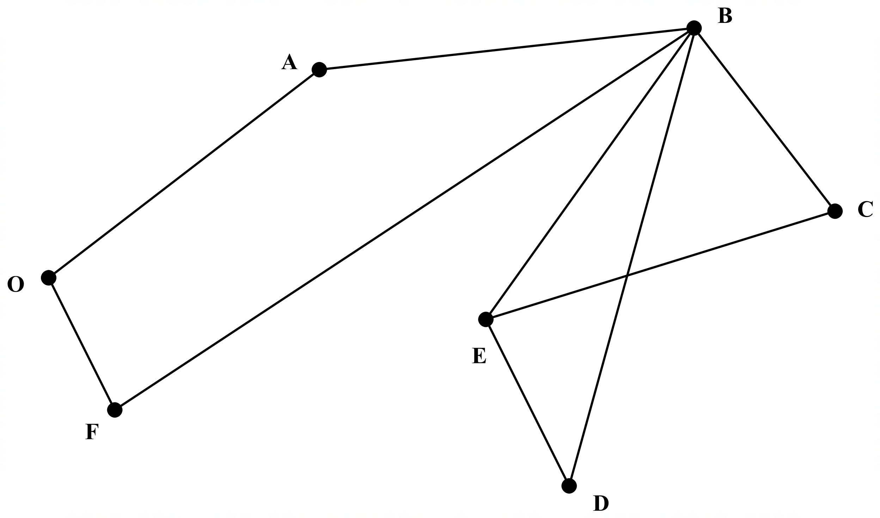

1. Explain why the completed graph can/cannot be described as a planar, simple and connected graph, justifying your decision. (3 marks)

The known direct distances (in kilometres) between each of the respective customers is tabulated below.

|  |  |  |  |  |  |  |
| --- | --- | --- | --- | --- | --- | --- |
| Customer | A | B | C | D | E | F |
| Office | 3 |  |  |  | 7 | 10 |
| A |  | 5 | 14 |  | 4 |  |
| B | 5 |  | 8 | 9 | 6 | 11 |
| C | 14 | 8 |  | 6 | 4 |  |
| D |  | 9 | 6 |  | 4 | 6 |
| E | 4 | 6 | 4 | 4 |  | 8 |
| F |  | 11 |  | 6 | 8 |  |

(c) Transfer the information provided on the table above onto your completed diagram for part (a). (2 marks)

1. The mortgage broker wants to identify a route that would allow him/her to visit each customer without going over any road more than once. Identify a route that could be used, starting and ending at the office and visiting customer A first. How long is his route? (2 marks)

(e) What is the name used to describe the route where the mortgage broker visits every customer starting and ending at the office and not repeating any roads? (1 mark)

**Question 3 (8 marks)**

Data for the number of schools (*s*) and the number of road accidents (*a*) within a medium-sized city were analysed. It was found that the correlation coefficient ${(r}_{sa})$ between these two variables was 0.72, the coefficient of determination ${(r^{2}}_{sa})$ was 0.5184 and the equation of the least-squares regression was $\hat{a}=2.21\hat{s}+4.59$.

(a) Using the correlation coefficient ${(r}_{sa})$, comment on the relationship between the two

Variables. (2 marks)

(b) In the context of the established variables, interpret the value of

(i) the coefficient of determination ${(r^{2}}_{sa})$. (1 mark)

(ii) the gradient from the least-squares regression equation. (1 mark)

(c) After showing a politician the raw and analysed data, the city’s mayor proposed that if more schools were merged then the number of road accidents would decrease. Identify and explain one possible reason the mayor of the city might have had to suggest this proposal. (2 marks)

(d) Outline and explain one possible non-causal explanation to account for the observed association between the number of schools and the number of road accidents in this city. (2 marks)

**Question 4 (7 marks)**

Ryan and Sam worked for a logistics company and are trying to find storage spaces for shipping containers. So far, they have received information from four contractors with space available in four different locations, as shown in the table below:

|  |  |  |  |  |
| --- | --- | --- | --- | --- |
|  | **Location** | | | |
|  | **A** | **B** | **C** | **D** |
| **Contractor 1** | 10 | 6 | 8 | 8 |
| **Contractor 2** | 7 | 5 | 9 | 10 |
| **Contractor 3** | 3 | 6 | 3 | 8 |
| **Contractor 4** | 5 | 5 | 5 | 3 |

Ryan and Sam decided to use a Hungarian Algorithm to allocate each contractor with a location, that will maximise their storage capabilities. The first step in their working is displayed below:

|  |  |  |  |  |  |  |  |  |  |  |
| --- | --- | --- | --- | --- | --- | --- | --- | --- | --- | --- |
| *Ryan’s working* | **Location** | | | |  | *Sam’s working* | **Location** | | | |
| **A** | **B** | **C** | **D** |  | **A** | **B** | **C** | **D** |
| **Contractor 1** | 4 | 0 | 2 | 2 |  | **Contractor 1** | 0 | 4 | 2 | 2 |
| **Contractor 2** | 2 | 0 | 4 | 5 |  | **Contractor 2** | 3 | 5 | 1 | 0 |
| **Contractor 3** | 0 | 3 | 0 | 5 |  | **Contractor 3** | 7 | 4 | 7 | 2 |
| **Contractor 4** | 2 | 0 | 2 | 0 |  | **Contractor 4** | 5 | 5 | 5 | 7 |

(a) Which employee has the correct values? Justify your answer. (2 marks)

(b) Continue using the algorithm to allocate each contractor a location to maximise the company’s storage space. (5 marks)

|  |  |  |  |  |  |  |  |  |  |  |  |
| --- | --- | --- | --- | --- | --- | --- | --- | --- | --- | --- | --- |
|  | **Location** | | | |  |  |  | **Location** | | | |
|  | **A** | **B** | **C** | **D** |  |  | | **A** | **B** | **C** | **D** |
| **Contractor 1** |  |  |  |  |  | **Contractor 1** | |  |  |  |  |
| **Contractor 2** |  |  |  |  |  | **Contractor 2** | |  |  |  |  |
| **Contractor 3** |  |  |  |  |  | **Contractor 3** | |  |  |  |  |
| **Contractor 4** |  |  |  |  |  | **Contractor 4** | |  |  |  |  |

|  |  |  |  |  |  |  |  |  |  |  |  |
| --- | --- | --- | --- | --- | --- | --- | --- | --- | --- | --- | --- |
|  | **Location** | | | |  |  |  | **Location** | | | |
|  | **A** | **B** | **C** | **D** |  |  | | **A** | **B** | **C** | **D** |
| **Contractor 1** |  |  |  |  |  | **Contractor 1** | |  |  |  |  |
| **Contractor 2** |  |  |  |  |  | **Contractor 2** | |  |  |  |  |
| **Contractor 3** |  |  |  |  |  | **Contractor 3** | |  |  |  |  |
| **Contractor 4** |  |  |  |  |  | **Contractor 4** | |  |  |  |  |

**Allocation:** Contractor 1: ____________

Contractor 2: ____________ Total number of storage spaces: _______

Contractor 3: ____________

Contractor 4: ____________

**Question 5 (9 marks)**

The number of vehicles that pass a certain check point is recorded over time periods *t,* and the following spreadsheet was produced that compares different moving averages.

|  |  |  |  |  |  |
| --- | --- | --- | --- | --- | --- |
| **t** | **Number of vehicles** | **3-point MA** | **4-point MA** | **5-point MA** | **6-point MA** |
| 1 | 850 |  |  |  |  |
| 2 | 920 | 903 |  |  |  |
| 3 | 940 | 920 | 905 | 896 |  |
| 4 | 900 | 903 | 896 | 892 | 891 |
| 5 | 870 | 867 | 883 | 892 | 898 |
| 6 | 830 | 873 | 884 | 890 | 893 |
| 7 | 920 | 893 | 889 | 886 | 884 |
| 8 | 930 | 910 | 893 | 882 | 876 |
| 9 | 880 | 887 | 883 | **B** | 878 |
| 10 | 850 | 850 | 868 | 878 | 885 |
| 11 | 820 | 860 | 870 | 876 | 879 |
| 12 | 910 | 883 | 876 | 872 | 869 |
| 13 | 920 | 897 | 879 | 868 |  |
| 14 | 860 | 870 |  |  |  |
| 15 | 830 | 832 |  |  |  |
| 16 | **A** |  |  |  |  |

1. For what purpose might the moving averages for the time series data have been calculated? (1 mark)
2. Determine the values of A and B in the above table, clearly showing your calculations. (4 marks)

The graph below shows the number of vehicles plotted over the time periods .

1. Use the information in the table/graph to decide which moving average is the most appropriate to consider. Justify your choice. (2 marks)
2. Describe the trend (if any) that is discernable from the data. (2 marks)

**Question 6 (8 marks)**

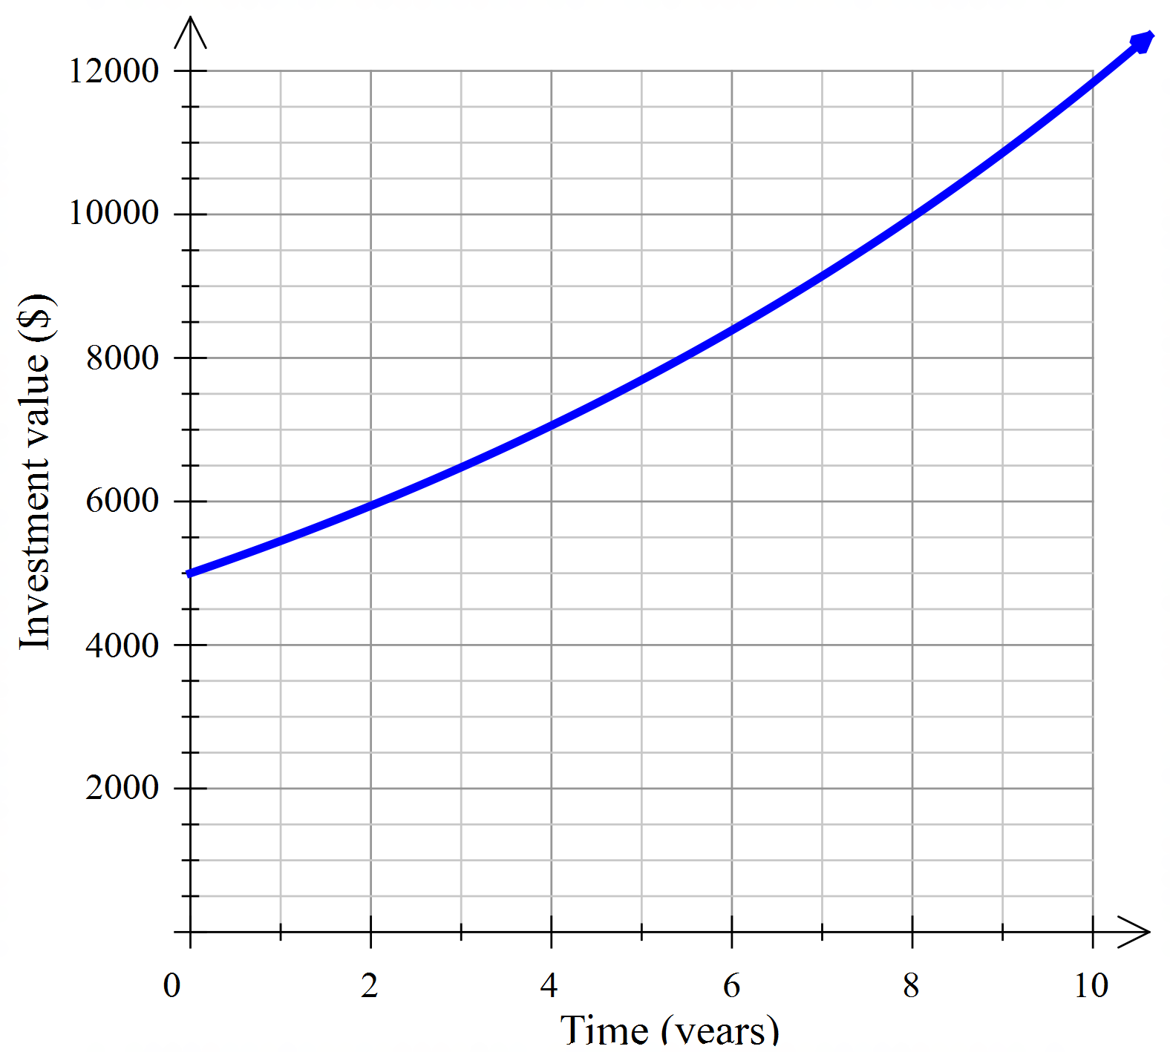The Best Investment Company advertises that the members’ investments grow at an average of 9% per annum. The graph below uses this growth rate to show the likely growth of Janina’s investment over the next 10 years when she does not make any further contributions to her account.

(a) Determine:

(i) the recurrence relation that models the growth of this investment. (3 marks)

(ii) a general rule for the  term of this investment. (3 marks)

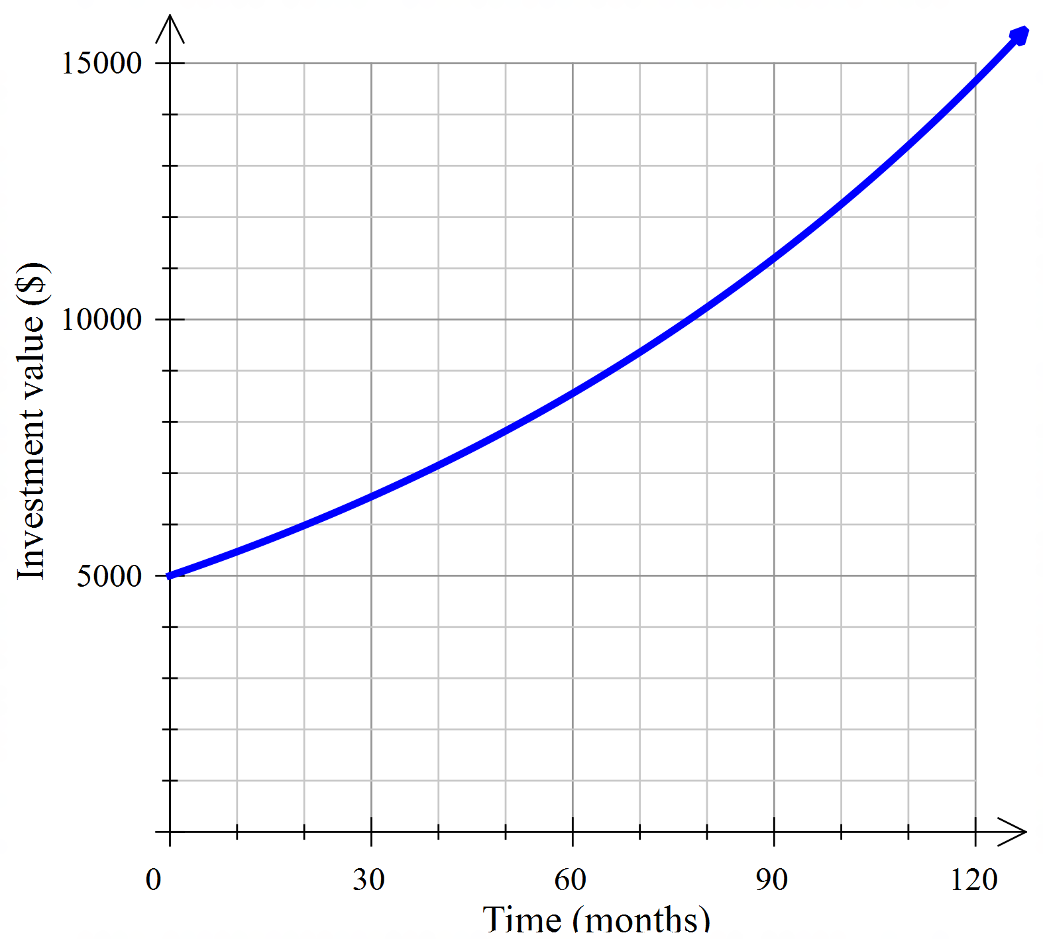The diagram below is a different graph of Janina’s investment where the annual interest has not changed but the interest has been calculated and added to the account monthly.

(b) What is the monthly rate of interest used for this investment? (1 mark)

(c) Use the two graphs to estimate the difference in the final value of Janina’s investments when the interest is determined monthly instead of annually. (2 marks)

**End of Questions**

Additional working space

Question number: __________________

© MAWA, 2019

This examination is Copyright but may be freely used within the school that purchases this licence.

* The items that are contained in this examination are to be used solely in the school for which they are purchased.
* They are not to be shared in any manner with a school which has not purchased their own licence.
* The items and the solutions/marking keys are to be kept confidentially and not copied or made available to anyone who is not a teacher at the school. Teachers may give feedback to students in the form of showing them how the work is marked but students are not to retain a copy of the paper or marking guide until the agreed release date stipulated in the purchasing agreement/licence.

*Published by The Mathematical Association of WA*

*12 Cobbler Place, MIRRABOOKA 6…*

**Acknowledgements**